**Supplementary Table**

**Table of Contents**

**Table S1.** Cervical cancer data description……………………………………………….....**Page 2**

**Table S2.** Identification of Biological Processes (BPs) of key genes from three databases (DAVID, Enrichr, and WebGestalt)………………………………………………………... **(See Excel File)**

**Table S3.** Identification of Cellular Components (CCs) of key genes from three databases (DAVID, Enrichr, and WebGestalt)………………………………………………. **(See Excel File)**

**Table S4.** Identification of Molecular Functions (MFs) of key genes from three databases (DAVID, Enrichr, and WebGestalt)...………………….…………………………. **(See Excel File)**

**Table S5.** Identification of KEGG pathways of key genes from three databases (DAVID, Enrichr, and WebGestalt)…………………....………………….…………………………. **(See Excel File)**

**Table S6.** Identification of Reactome pathways of key genes from three databases (DAVID, Enrichr, and WebGestalt)...………………....………………….………………..... **(See Excel File)**

**Table S7.** Identification of WikiPathways of key genes from three databases (DAVID, Enrichr, and WebGestalt)......……………...………....………………….……………….... **(See Excel File)**

**Table S8.** Binding Affinity Score (BAS)………………………………………... **(See Excel File)**

**Table S9**. Collection of gene entities from the literature review…………………………**Page 2-5**

**Table S10**. The average values of RMSD, RMSF, SASA, Radius of gyration (Rg), and MM-PBSA binding free energy for the highest-ranked protein-ligand complexes…………………….. **Page 5**

**Fig S1.** Top five hub genes obtained from the literature review through the PPI network analysis………………………………………………………………………………………**Page 7**

**Table S1.** Cervical cancer data description.

|  |  |  |  |  |  |
| --- | --- | --- | --- | --- | --- |
| **Data Type** | **NCBI-Accession ID** | **Countries of Data Collection** | **Array Type/ Platform** | **No. of Genes** | **No. of Patients**  **(Case/Control)** |
| Microarray | GSE7803 | USA | [HG-U133A] Affymetrix Human Genome U133A Array | 22283 | 21/10 |
| GSE9750 | USA | 22283 | 33/24 |
| RNA-Seq | GSE168244 | Netherlands | Illumina NextSeq 500 (Homo sapiens) | 37237 | 17/18 |
| GSE149450 | China | HiSeq X Ten (Homo sapiens) | 25382 | 2/2 |

**Table S9**. Collection of gene entities from the literature review.

| **Serial No.** | **Gene Entities** | **Ref.** |
| --- | --- | --- |
|  | CDKN2A, VEGFA, PTGS2, MCM2, MCM4, MCM6, KRT1, KRT10, and STAT1. | [1] |
|  | *MCM10.* | [2] |
|  | *EZH2, FLT1, IGF2, IRS1, JUN, KDR, SOX2, MYB, ZEB1, TIMP2.* | [3] |
|  | *LONRF2, CCNE2, AURKA, SYT1, NEGR1, PPP1R12B, GABRP, RAD51, CDK1, FBLN5, PRKG1, CDC6, CACNA1C, MEOX2, ANLN, MYLK,* and *EDNRB.* | [4] |
|  | *PLOD1, PLOD2, ITGA3, ITGA6, LAMC1, AGRN, MCAM, PARVA,* and *NRP2.* | [5] |
|  | *VEGFA, PIK3R1, BCAR1, AR, CPT1A, ACSL3, ACSL4, IGF1R, LPL,* and *HMGCR.* | [6] |
|  | *CDK1, CCNB1, CDC20, TOP2A, MAD2L1, NDC80, AURKA, ASPM, NCAPG,* and *BIRC5.* | [7] |
|  | *eEF1A2.* | [8] |
|  | *CDK1, CDC20, AURKA, TOP2A, ASPM, NCAPG, KIF23, CENPF, KIF20A,* and *PRC1.* | [9] |
|  | *SOX9*. | [10] |
|  | *MCM4, NUSAP1, CDCA5, CDC45, DTL,* and *CDT1.* | [11] |
|  | EMEMP2, GIMAP4, DYNC2I2, FGF13-AS1, and GIMAP1. | [12] |
|  | *Beclin1.* | [13] |
|  | *CDK1.* | [14] |
|  | *AURKA, BRCA1, CCNB1, CDK1, MCM2, NCAPG2,* and *TOP2A.* | [15] |
|  | *PRMT5.* | [16] |
|  | *CDK1, CDK2, CHEK1, MKI67, TOP2A, BRCA1, PLK1, CCNA2, CCNB1, TYMS.* | [17] |
|  | *NRAS, GRB2, BRAF, CCND2,* and *CCNE1.* | [18] |
|  | *AURKA, TOP2A, RFC4,* and *CEP55.* | [19] |
|  | *EZH2.* | [20] |
|  | *KIF2C, RAD21, MAD2LI, TOP2A, BIRC5, KIF11, MCM5, PCNA, MCM4,* and *SMC3.* | [21] |
|  | SCNN1A, SCNN1B, and SCNN1G. | [22] |
|  | *CX3CL1, SCML4, LYZ, FGD2, SLAMF6, GIMAP7, CCL19, SELP* and *POU2AF1.* | [23] |
|  | *APOD, ARMCX1, GALNT3, HK2* and *HLF.* | [24] |
|  | *CDC45, MCM2, PCNA* and *TOP2A*. | [25] |
|  | *CCNE1, CCNE2, ANLN, RACGAP1, KIF23, CHEK1, CDC25A, E2F7, CDK1,* and *CEP55.* | [26] |
|  | *P4HA2, MSMO1, EGLN1, ZNF316, IKZF3, ISCU, MYO1B*. | [27] |
|  | *PLOD2, SPON1, SPP1, RNASEH2A.* | [28] |
|  | *CMTM6.* | [29] |
|  | *HBP1, HIF1A, HLTF, LRPPRC, TGFBR1, DDX17, CNOT1, ZNF664, WAC, PTPN14, KRT18, BCL2L1, ANGPTL4, CTGF, EPHA2.* | [30] |
|  | *CXCL10, CGB5, CXCL12, PTX3,* and *CXCL9.* | [31] |
|  | *MCM3.* | [32] |
|  | *KLRK1, LCK, KIF20A, CD247, FASLG, CD163, ZAP70, CD8B, ZNF683,* and *F10.* | [33] |
|  | *NUSAP1, TOP2A, KIF2C, NDC80, ASPM, KIF20A, CDK1, KIF11, BIRC5, MCM2,* and *CHEK1.* | [34] |
|  | *DNMT1, CHAF1B, CHAF1A, MCM2* and *CDKN2A.* | [35] |
|  | *FOXA1, OSA1, IRF3, STAT1, BMP4, MEF2C, TBX2* and *PTN.* | [36] |
|  | *SLC25A5, ENO1, ANLN, RIBC2, PTTG1,* and *MCM5.* | [37] |
|  | *CXCL1, CXCL8, CXCL9, CXCL10, CXCL11, CXCL13, CXCL16, CXCL17.* | [38] |
|  | *CDC45, RFC4, TOP2A, CCNA2, CCNB2, MCM6, KIF11, KIF20A, UBE2C* and *FEN1.* | [39] |
|  | *FANCI.* | [40] |
|  | *RFC5, POLE3, RAD51, RMI1, PALB2, HDAC1, MCM4, ESR1, FOS* and *E2F1.* | [41] |
|  | *STAT1.* | [42] |
|  | *SPP1, MELK, TTK, ARRB2, FOXM1, LYN, CCL21,* and *COL6A3.* | [43] |
|  | *PYGM, BMF, MBNL3, DENND6A, REEP5, KLF6* and *ITM2C*. | [44] |
|  | *CDC45, GINS2, MCM2,* and *PCNA.* | [45] |
|  | *LGR6, SYCP2, TCAM1P,* and *RUNX3.* | [46] |
|  | *CDH2, VIM, FN1, ZEB1, ZEB2, SNAI1, SNAI2, TWIST1, TWIST2, ERBB2, GATA3, and CDH1.* | [47] |
|  | *p53.* | [48] |
|  | *ESR1, EPB41L3, EDNRB, ID4, PLAC8.* | [49] |
|  | *MELK, CDK1, BUB1B, NCAPG, KIF11, PBK, TOP2A, TTK, DLGAP5, ASPM, DTL, CCNB1, CDC6, RAD51AP1, KNTC1, KIF15,* and *NDC80.* | [50] |
|  | *RRM2, CDC45, GINS2, HELLS, KNTC1, MCM2, MYBL2, PCNA, RAD54 L, RFC4, RFC5, TK1, TOP2A,* and *TYMS.* | [51] |
|  | *CDC6, CDK1, CDC45, BUB1, TOP2A, MCM4, CCNB2* and *CCNB1*. | [52] |
|  | *SYCP2, TCAM1P, DCLRE1B, CDC7, TOPBP1, ACTL6A, CKLF, C18orf54, CENPQ, ATAD2, PRIM2, RAD54L, EXO1, KIAA0101, HENMT1, TOP2A, NCAPH, ZWILCH, LINC00925, CENPO, ZFR2, RIBC2, SYNGR3, ASPM, LOC375196, RFC4, DHFR, CDKN2A, MLF1, CDC45.* | [53] |
|  | *CCR7, CD28, PD-1, and ZAP70.* | [54] |
|  | *PLOD2, ANLN, AURKA, and AR.* | [55] |
|  | *ANXA2.* | [56] |
|  | *OTUD5.* | [57] |
|  | *CDC20, CDK1, UBE2C, TOP2A, CCNB2, NUSAP1, KIF20A, AURKA, CEP55,* and *ASPM.* | [58] |
|  | *TCF19, CDCA8, CENPO, CCNA2, KIF2C, KIF4A, RACGAP1, ORC1L, KIFC1, MELK, PCMTD1, TP53INP1, ZNF582, ZNF737, TMEM150A, ZNF248, LOC144571, FAM171A1, ZNF626, RNF170.* | [59] |
|  | *TYMS, TOP2A, MCM2, HELLS, CXCL8, ECT2, WDHD1, FANCI, DTL, CEP55, CDK1, AURKA.* | [60] |
|  | *CDK1, BUB1, CENPK, ZWILCH, DSN1, RCC2, and RANGAP1.* | [61] |
|  | *TROAP, KIF18B, CDC6, NEK2, CDCA8, PGM5-AS1, TRPC4, TCEAL6, CNN1, PTGER3.* | [62] |
|  | *ESR1, PPP1R3C, NSG1, TMPRSS11D, GYS2, ENDOU, and KLF4.* | [63] |
|  | *TSPO, CCND1, FOS, CDK1, TOP2A, CCNB1, PCNA, BIRC5* and *MAD2L1.* | [64] |
|  | *CCND1, CTNNB1, MAPK10,* and *PRKCA.* | [65] |
|  | *FOXO1, KLF5, PRLR, THBS1, CCNB1, BCL2, IGFBP5, BAK1, FGF2, TXNIP, MYB, AKT3, IDH2, FLI1, CDC25A, SLC43A1,* and *MYB.* | [66] |
|  | *AKR1B10, ANXA8, ANXA8L2, BNC1, CLCA2, CSTA, DSC3, FBXO27, FOXE1, GBP6, GJB6, GPR109A, GPR115, GPR87, IVL, KRT6A, KRT6B, KRT6C, LOC642587, NCCRP1, PKP1, PLAC2, RHCG, SBSN, SERPINB13, SERPINB2, SERPINB4, SOX15, SPRR1A, SPRR2A, SPRR2D, TMEM40, TMPRSS11D, TP63 and VSNL1.* | [67] |
|  | *RhoB, STMN1, CCNB1.* | [68] |
|  | *CDK1, TOP2A, AURKA, MCM2 and KIF20A.* | [69] |
|  | *AURKA, BIRC5, BUB1, CDC20, CDC45, CDK1, CDKN2A, CENPA, CKS1B, CKS2, DNMT1, GINS2, HLTF, KIF11, KIF23, KIF2C, MCM5, MCM6, NDC80, NEK2, NUSAP1, PLAU, POLE2, PRC1, RAD51AP1, RFC4, RFC5, SMC4, STMN1, SYCP2, TACC3, TIMELESS, TK1, TOP2A, TOPBP1, TPX2, TTK, TYMS; CDA, CFD, CRNN, EDN3, ENDOU, GSTA4, LDOC1, PDGFD, PPP1R3C, UPK1A.* | [70] |
|  | *CDK1, CCNA2, MAD2L1, KIF11, RRM2, and PBK.* | [71] |
|  | *CBX4, PLK4, PSMD14, CHEK1, AURKA, NRAS, GAPDH, PARP1, FLNA, PSMA4, BRCA2, ZBTB16, BAX, ANKRD9, TRIM11, NDFIP2, SNX9, IVNS1ABP, RNF150.* | [72] |
|  | *CCNE1, CCNE2, ANLN, RACGAP1, KIF23, CHEK1, CDC25A, E2F7, CDK1, CEP55.* | [73] |
|  | *TNF, IFNG, MMP3, FLT1, PLAU, NRP1, PTX3, BCL2, SERPINF1, SLC7A5, ANXA5.* | [74] |
|  | *ITGB1, CCL2, STRN3, EDN1.* | [75] |
|  | *A2ML1.* | [76] |
|  | *EGLN1, AKTIP, ANGPT2, SERPINE1, EGFR, PRKCB, CAMK2N2, IFNG, PIK3R2.* | [77] |
|  | *S100A2, ZWINT, KIFC1, MMP9, PLK1, CDC6, HMGA1, SLC7A5, HIST1H2BJ, UBALD2.* | [78] |
|  | *FAT2, ZNF750, TP63, A2ML1, CLCA4, CD276, LAG3, PDCD1, TNFRSF8, TNFSF14, CD40LG, CD44, ICOSLG, TNFSF15, VTCN1, TTN, PIK3CA, KMT2C, MUC4, ADH7, CALML3, CALML5, CYP4B1, FGFR3, PSCA, RAPGEFL1, SCNN1B.* | [79] |
|  | *TGFβ-1, TRIM26, CCPG1, MTR, LGMN, SLC38A2, ATP6AP1, CIRBP, PTP4A1, IGFBP7, CYR61, CKAP5, CLPTM1, FAM120A, TMX2, NCSTN.* | [80] |
|  | *ATF5, PARM1, TRAF2, LTB, KRT36, NINJ1, ATP6V1D, PLIN3, NDFIP2, SSH3, AHNAK.* | [81] |
|  | *IL24, ANKRD22, ACOX2, CXCL8, CRYAB, SPP1.* | [82] |
|  | *AC123032.1, LINCO2582, GAGE2A, REG3A, SOHSL1, TRIM53CP, GSTA1, AMBN, AL033397.1, TRIM49, KIF1A, SLC26A3, LINC01811, CT45A1, ALOX15P2, AC009831.2, GPX6, HOXC12, TRIM49B, AC097713.2, TRIM43, FLJ36000, FGF99, HELT, KRTAP19-1, ZIC3, LINC01639, NMRAL2P, AL163953.1, LINC02492, LINC02620.* | [83] |

**Table S10**. The average values of RMSD, RMSF, SASA, Radius of gyration (Rg), and MM-PBSA binding free energy for the highest-ranked protein-ligand complexes.

|  |  |  |  |  |  |  |
| --- | --- | --- | --- | --- | --- | --- |
| **Name of Complex** | **MD Simulation Study** | | | |  |  |
| **Average RMSD**  **(****Å)** | **Average RMSF**  **(****Å)** | **Average SASA**  **(Å)** | **Average Rg**  **(Å)** | **Average BFE**  **(Å)** |  |
| CDK1 *vs.* Ponatinib | 1.56 | 1.24 | 14406.60 | 20.47 | 146.64 |  |
| CDC20*vs.* Irinotecan | 1.12 | 0.905 | 12422.81 | 18.64 | 153.96 |  |
| TOP2A*vs.*Pazopanib | 3.45 | 1.69 | 19010.49 | 23.16 | 252.47 |  |

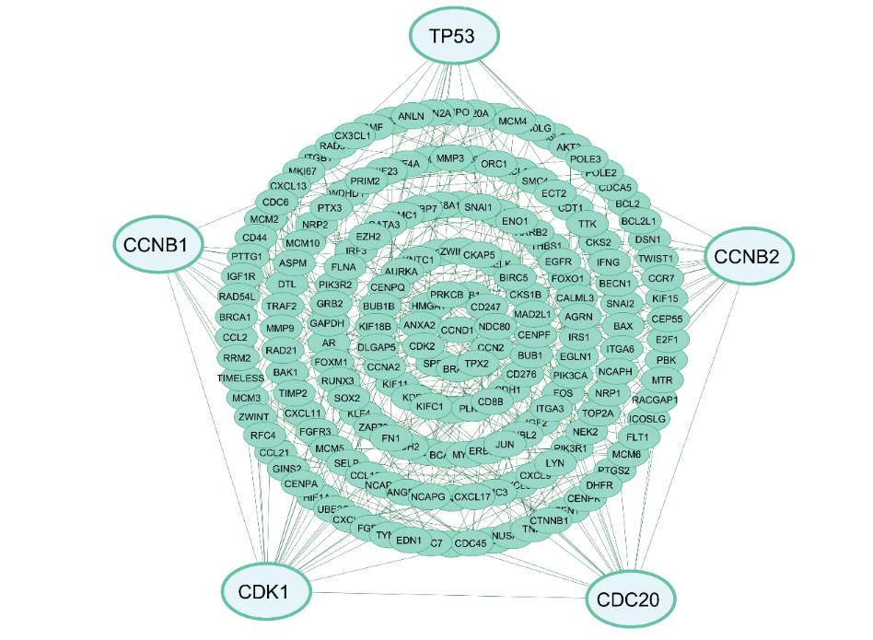

**Fig S1.** The top five hub genes were obtained from the literature review through the PPI network analysis.